Chocolatey Chip Cookie Dough 1oz
INGREDIENTS: wheat flour, sugar, confectionary drops (sugar, vegetable fat [palm, coconut], cocoa powder, sunflower lecithin, vanilla), palm oil, water, invert sugar, egg replacer (soy flour, wheat gluten, corn syrup solids, algin), molasses, salt, wheat gluten, baking soda, artificial vanilla flavor, potassium sorbate.
CONTAINS SOY, WHEAT.
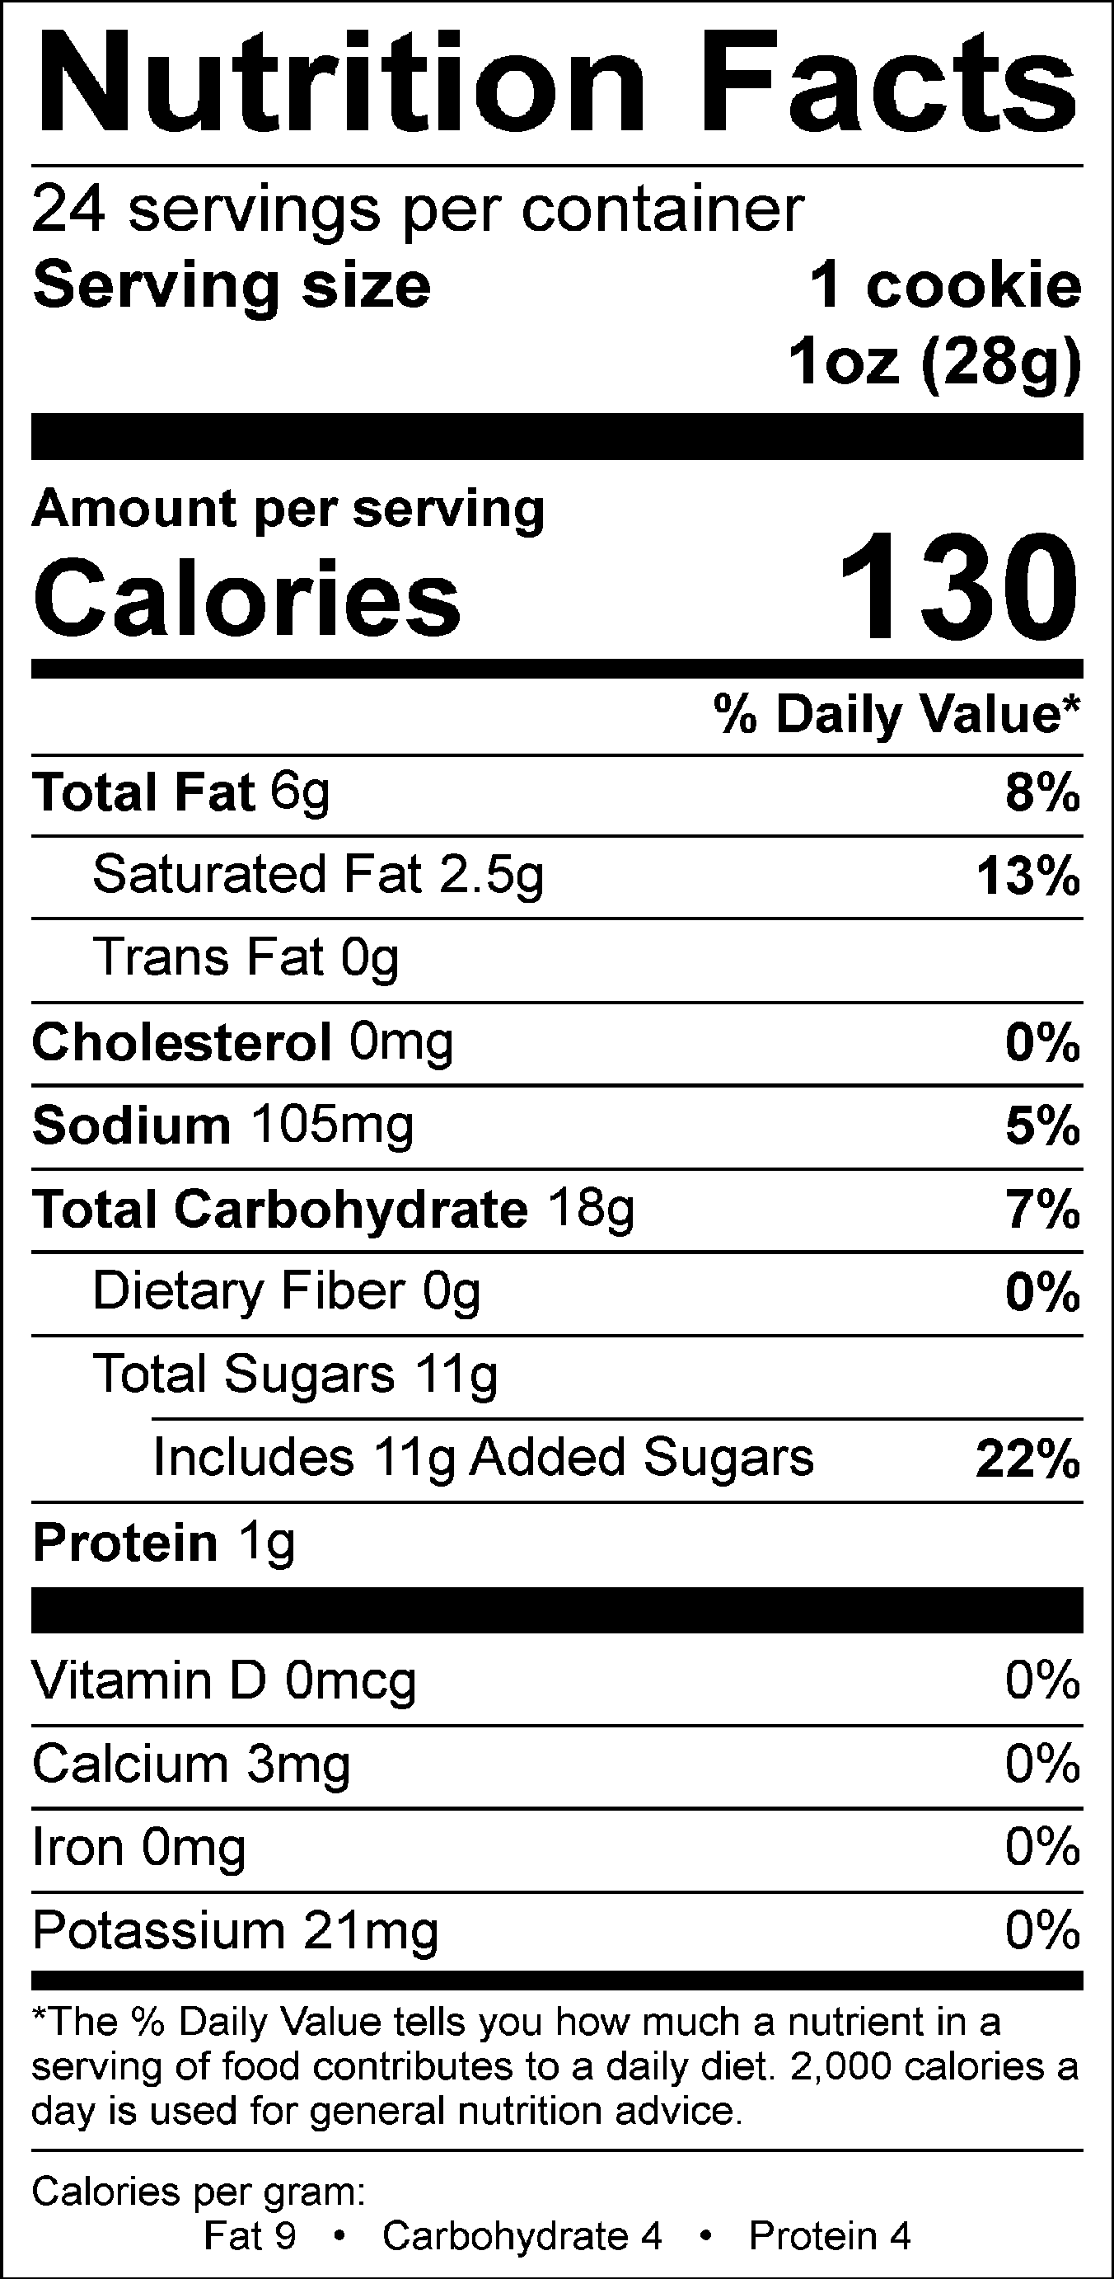

Snickerdoodle Cookie Dough, 1oz
INGREDIENTS: wheat flour, sugar, palm oil, water, invert sugar, egg replacer (soy flour, wheat gluten, corn syrup solids, algin), wheat gluten, salt, baking soda, artificial vanilla flavor, cinnamon, potassium sorbate.
CONTAINS SOY, WHEAT.
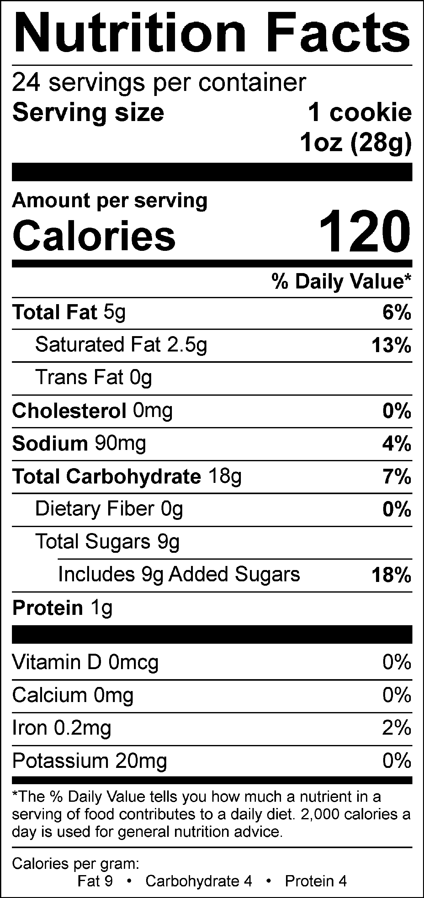

Oatmeal Raisin Cookie Dough, 1oz
INGREDIENTS: wheat flour, sugar, palm oil, raisins, rolled oats, water, invert sugar, egg replacer (soy flour, wheat gluten, corn syrup solids, algin), molasses, salt, baking soda, artificial vanilla flavor, cinnamon, potassium sorbate.
CONTAINS SOY, WHEAT.
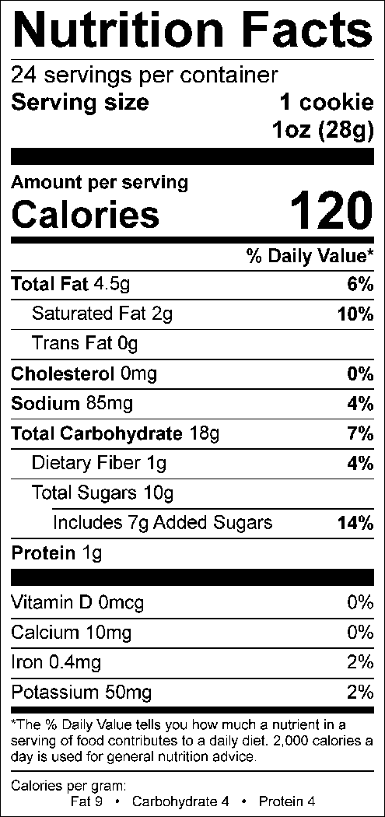

Peanut Butter Cookie Dough, 1oz
INGREDIENTS: wheat flour, sugar, palm oil, peanut butter (roasted peanuts, dextrose, hydrogenated cottonseed and canola oils, salt), water, invert sugar, egg replacer (soy flour, wheat gluten, corn syrup solids, algin), molasses, salt, baking soda, natural peanut flavor, artificial vanilla flavor, potassium sorbate.
CONTAINS PEANUT, SOY, WHEAT.
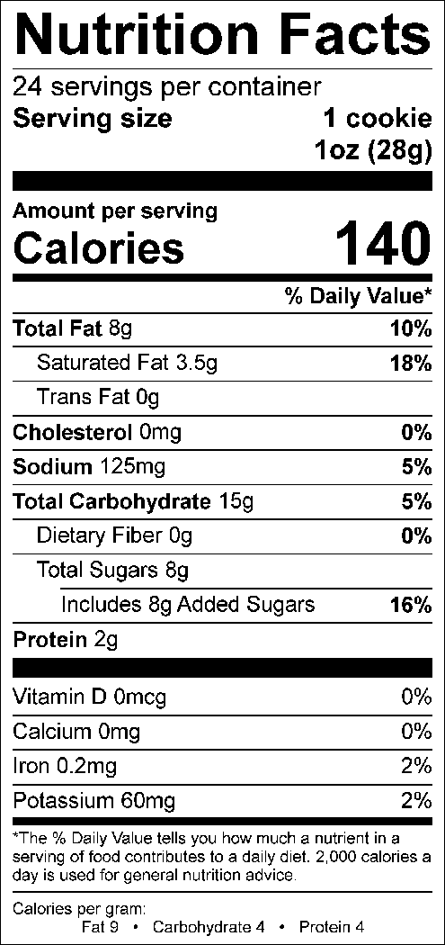

Apple Caramel Cookie Dough, 1oz
INGREDIENTS: wheat flour, sugar, palm oil, rolled oats, caramel chips (sugar, palm kernel oil, palm oil, nonfat dry milk, whole milk, cocoa powder, soy lecithin, salt, natural flavor, paprika extract for color), dried apple (preserved with sulfite), water, invert sugar, egg replacer (soy flour, wheat gluten, corn syrup solids, algin), molasses, baking soda, salt, natural & artificial apple flavor, cinnamon, potassium sorbate.
CONTAINS MILK, SOY, WHEAT.
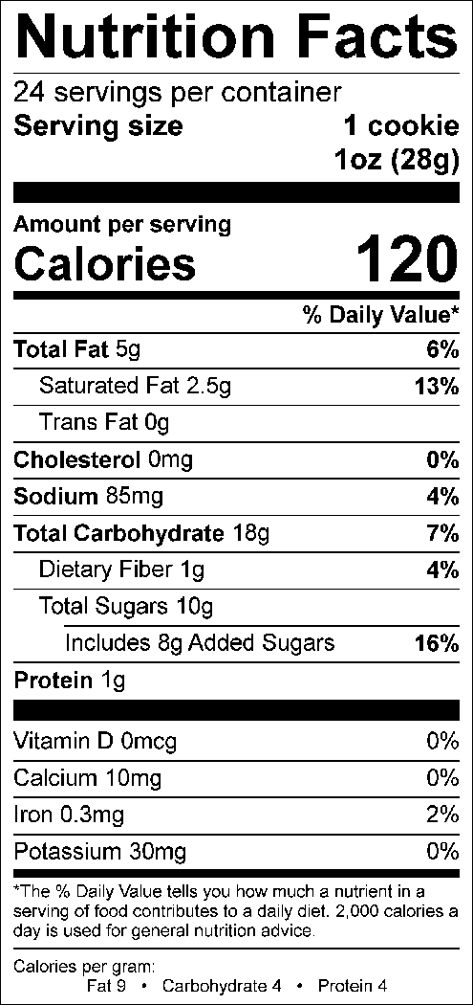

White Chip Macadamia Cookie Dough, 1oz
INGREDIENTS: wheat flour, sugar, palm oil, white chips (sugar, palm kernel and/or palm oil, non-fat dry milk, soy lecithin, natural vanilla extract), water, macadamia nuts, invert sugar, egg replacer (soy flour, wheat gluten, corn syrup solids, algin), wheat gluten, salt, baking soda, artificial vanilla flavor, potassium sorbate.
CONTAINS MILK, SOY, TREE NUTS (MACADAMIA), WHEAT.
